The Daily Exercise of Piety (1629) by Johann Gerhard

(from the “Dedication” and continued from last week)

The third truth which assures us that God favorably hears our prayers is the intercession of Christ the Mediator. For He is "at the right hand of God and intercedes for us [Rom. 8:34], and is our Advocate with the Father." [ I John 2:11] What will the heavenly Father deny to His most beloved Son? What will our most gracious Savior not obtain by the power and merit of His satisfaction accomplished for us? The shrine of heaven stands open to Him. He delivers our prayers into the secret council of God. Will the Father not hear Him? Will He refuse anything to Him? Will He not hear Himself? Will He refuse Himself anything? For the Father and the Son "are one." [John 10:30] The Son is "in the bosom of the Father." [John 1:18] And "the Son is in the Father and the Father in the Son." [John 10:38, 14:10] Christ our Intercessor says to the Father, "I know that You always hear Me" [John 11:42] If He was heard by the Father while He walked upon the earth as God in the flesh, appearing in weakness in the state of humiliation [Phi. 2:7], the Father will certainly hear Him now in His state of exultation [Phi. 4:10] as He rules in all the glory of His majesty and exercises the full measure of His power!

(continued next week)
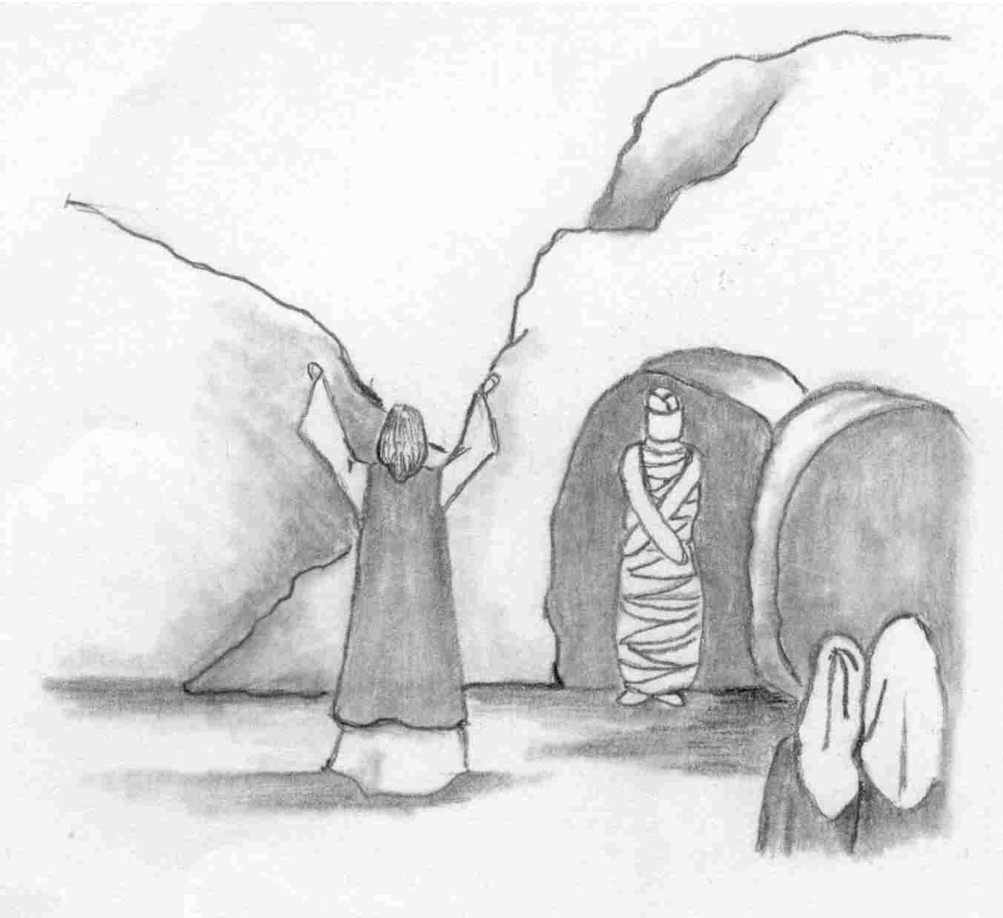

When He had said this, He cried with
a loud voice, "Lazarus, come out."

Our Redeemer Lutheran Church
403 South Hayes
Emmett, Idaho 83617 Church: 208-365-5231

Pastor: Rev. Michael L. McCoy
parsonage: 208-365-5214
email: mmccoy19@earthlink.net
www.scholia.net – the website for:
Good News for the Diaspora!
Music, Litany and Sermons for the Diaspora!
scholia.net publishing – Where the Word is not Bound
Predici in limba romana – (Sermons in Romanian)
The artwork is by Sharon Geiser. Permission to use this copyrighted graphic is limited to congregational use. For information on The Daily Exercise of Piety by Johann Gerhard and other books from Repristination Press see the website below.

This bulletin cover provided by www.scholia.net and is made available without cost.

13 March Anno Domini 2005

The Fifth Sunday in Lent

When He had said this, He cried with
a loud voice, "Lazarus, come out."
To place the graphic on this page:
Copy the graphic on the previous page.
Click on the open space above and a graphic box should appear. Paste the graphic.

Change this frame and the box above by clicking the body of the text and adding the particulars. (See the previous page for an example.)
The artwork is by Sharon Geiser. Permission to use this copyrighted graphic is limited to congregational use. For information on The Daily Exercise of Piety by Johann Gerhard and other books from Repristination Press see the website below.

This bulletin cover provided by www.scholia.net and is made available without cost.

13 March Anno Domini 2005

The Fifth Sunday in Lent

The Daily Exercise of Piety (1629) by Johann Gerhard

(from the “Dedication” and continued from last week)

The third truth which assures us that God favorably hears our prayers is the intercession of Christ the Mediator. For He is "at the right hand of God and intercedes for us [Rom. 8:34], and is our Advocate with the Father." [ I John 2:11] What will the heavenly Father deny to His most beloved Son? What will our most gracious Savior not obtain by the power and merit of His satisfaction accomplished for us? The shrine of heaven stands open to Him. He delivers our prayers into the secret council of God. Will the Father not hear Him? Will He refuse anything to Him? Will He not hear Himself? Will He refuse Himself anything? For the Father and the Son "are one." [John 10:30] The Son is "in the bosom of the Father." [John 1:18] And "the Son is in the Father and the Father in the Son." [John 10:38, 14:10] Christ our Intercessor says to the Father, "I know that You always hear Me" [John 11:42] If He was heard by the Father while He walked upon the earth as God in the flesh, appearing in weakness in the state of humiliation [Phi. 2:7], the Father will certainly hear Him now in His state of exultation [Phi. 4:10] as He rules in all the glory of His majesty and exercises the full measure of His power!

(continued next week)

